East Area Planning Committee | 2 September 2015

Application Number: | 15/02061/FUL
Decision Due by: | 9th September 2015
Proposal: | Increase in ridge height of garage roof. (Retrospective). Conversion of garage into 1 x 1-bed annexe (Use Class C3)
Site Address: | 3 David Nicholls Close. Site plan at Appendix 1
Ward: | Littlemore Ward

Agent: | JPPC Chartered Town Planners | Applicant: | Mr David Henwood

Recommendation:

APPLICATION BE APPROVED

For the following reasons:

1 The Council considers that the proposal accords with the policies of the development plan as summarised below. It has taken into consideration all other material matters, including matters raised in response to consultation and publicity. Any material harm that the development would otherwise give rise to can be offset by the conditions imposed.

2 The Council considers that the proposal, subject to the conditions imposed, would accord with the special character and appearance of the conservation area. It has taken into consideration all other material matters, including matters raised in response to consultation and publicity.

subject to the following conditions, which have been imposed for the reasons stated:-

1 Development begun within time limit

2 Develop in accordance with approved plans

3 Materials - matching

4 Restricted use

5 Sustainability design/construction

Main Local Plan Policies:

Oxford Local Plan 2001-2016

CP1 - Development Proposals
CP6 - Efficient Use of Land & Density
CP8 - Design Development to Relate to its Context
CP10 - Siting Development to Meet Functional Needs

Core Strategy

CS9_ - Energy and natural resources
CS10_ - Waste and recycling
CS18_ - Urban design, town character, historic environment

Sites and Housing Plan

MP1 - Model Policy
HP2_ - Accessible and Adaptable Homes
HP9_ - Design, Character and Context
HP11_ - Low Carbon Homes
HP12_ - Indoor Space
HP13_ - Outdoor Space
HP14_ - Privacy and Daylight
HP15_ - Residential cycle parking
HP16_ - Residential car parking

Other Material Considerations:

National Planning Policy Framework
This application is in or affecting the Littlemore Conservation Area.
Planning Practice Guidance

Relevant Site History:

Planning:

00/00724/NFH - Alterations to existing garage. Additional windows to front elevation, raising the roof to ridge height of 7.30m and the provision of a 1st floor for use as games room, sensory room and storage.. REF 11th July 2000.

02/00010/FUL - Alterations to existing garage including the introduction of additional windows to front elevation, raising the roof to a ridge height of 5.75 m and provision of a 1st floor. WDN 19th March 2002.

02/01542/FUL - Retention of existing garage, including first floor, with ridge height of 5.75 metres incorporating windows at first floor to front elevation, roof lights to rear elevation and false chimney as owl nesting box.. REF 14th October 2002.

90/00497/PN - Partial demolition of school as shown on drawings nos. L.12, L,14 and A02.. PER 13th February 1991.

90/00626/PN - Conversion of existing lodge to residential use and construction of 10 detached dwellings and garages. Construction of new type 4 access road off Sandford Road and closure of existing school access.. PER 28th June 1990.

90/00627/PN - Change of use of lodge from office use to residential use. Construction of new type 4 access road off Sandford Road and closure of existing school access.. PER 18th June 1991.

95/01437/NF - Land at Sandford Road - 11x2 storey dwellings, (5x4 bed with garages/parking spaces, 5x4 bed with detached double garages/parking space, 1x3 bed with detached double garage/parking spaces). Access road (closure of existing access) & footpath. PER 21st November 1995.

99/00126/NF - Extension at side and rear of existing garage.. PER 10th March 1999.

99/00928/NFH - Extension at side & rear of garage, raise walls of existing structure & provide new roof to provide storage in roof space & domestic workshop on ground floor. (Amendment to application 99/126/NF). PER 16th September 1999.

04/01550/FUL - Erection of canopy and insertion of windows at first floor level to front elevation. (Ammended Plan). REF 30th September 2004.

05/02177/FUL - Erection of canopy. Alterations to window. (Amended plans). REF 19th December 2005.

06/01569/VAR - Velux rooflight to rear elevation of garage (variation of condition 4 of planning permission 99/00126/NF). PER 22nd September 2006.

06/02014/VAR - Velux rooflights to rear elevation of garage (variation of condition 4 of planning permission 99/00126/NF) and erection of canopy to front.. PER 11th December 2006.

07/00561/VAR - Insertion of two rear first floor windows (variation of condition 4 of planning permission 99/00126/NF) (Amended plan). REF 4th May 2007.

08/00357/VAR - Four (in total) velux roof lights in rear elevation of garage (variation of condition 4 of planning permission 99/00126/NF). PER 7th May 2008.

08/00980/FUL - Retention of first floor window and screen to garage.. REF 10th July 2008.

08/01935/CEU - Application for a Lawful Development Certificate for the retention of 1st floor North facing window.. PER 27th October 2008.

08/02327/CEU - Application for a Lawful Development Certificate for the retention of a first floor north facing window.. PER 24th December 2008.

09/00019/CEU - Application for a lawful development certificate for the retention of a first floor north facing window.. PER 27th February 2009.

09/00729/FUL - Erection of canopy.. PER 3rd June 2009.

09/02797/FUL - Erection of car port.. REF 20th May 2010.

10/01412/FUL - Two storey front extension (amended description and plans).. REF 17th December 2010.

11/00394/FUL - Increase in ridge height of roof of garage to 5.85m. (Retrospective). REF 21st April 2011.

12/01722/CEU - Certificate of lawfulness to certify that the ridge height at 5.9m is lawful. REF 28th August 2012.

12/02105/FUL - Change of use of garage to 1-bedroom dwelling (class C3). (Amended plans). REF 10th October 2012.

Appeals

00/00724/NFH 00/00022/REFUSE - Alterations to existing garage. Additional windows to front elevation, raising the roof to ridge height of 7.30m and the provision of a 1st floor for use as games room, sensory room and storage.. DISMISSED 1st January 2001.

02/01542/FUL 03/00013/REFUSE - Retention of existing garage, including first floor, with ridge height of 5.75 metres incorporating windows at first floor to front elevation, roof lights to rear elevation and false chimney as owl nesting box.. DISMISSED 26th June 2003.

04/01550/FUL 04/00101/REFUSE - Erection of canopy and insertion of windows at first floor level to front elevation. (Amended Plan). DISMISSED 27th June 2005.

058/02177/FUL 06/00019/REFUSE - Erection of canopy. Alterations to window. (Amended plans). ALC 19th June 2006.

07/00561/VAR 07/00044/REFUSE - Insertion of two rear first floor windows (variation of condition 4 of planning permission 99/00126/NF) (Amended plan). DISMISSED 11th December 2007.

08/00980/FUL 08/00081/REFUSE - Retention of first floor window and screen to garage.. AWD 10th November 2008.

09/02797/FUL 10/00051/REFUSE - Erection of car port.. DISMISSED 18th August 2010.

10/01412/FUL 11/00017/REFUSE - Two storey front extension (amended description and plans).. DISMISSED 7th July 2011.

12/02105/FUL 13/00005/REFUSE - Change of use of garage to 1-bedroom dwelling (class C3). (Amended plans). DISMISSED 1st July 2013.

Representations Received:

13 Boswell Road: Support this development; will enable a Disabled man to live a supported life and enhance his quality of life and enable him to become more independent; alteration will have no impact on the neighbours or surrounding area; increased ridge height has no impact on any of his neighbours visual amenity.

Statutory and Internal Consultees:

No comments received

Issues:

- Principle/Loss of Garage
- Design
- Residential Amenity
- Sustainability
- Ridge Height (Including Background)

Officers Assessment:

Site Description

1. The application site comprises a detached two storey red brick garage building within David Nicholls Close associated with number 3. The building has a double garage, front porch with an adjoining room and a further room upstairs within the roof space.

2. Late 20th/early 21st century development has taken place along Sandford Road within Littlemore in the form of David Nicholls Close and the Speedwell School site. David Nicholls Close provides driveway access to Lawn Upton School and has now been developed with detached houses. A semblance of open character has been retained despite the development due to the set back position of the houses and their open front gardens. The houses do not impact upon the appearance of the main road as they are mainly tucked away behind Lawn Upton Lodge and the curve of the road prevents clear views along the close from the main road.

Proposal

3. The application is seeking permission to convert the garage to an annex to provide ancillary living accommodate to the main dwelling. This will involve the loss of one of the garage parking bays which is to be replaced with a window. Planning permission is required for the conversion of the garage due to condition 11 of 95/01437/NF which requires the garages to be reserved for the occupants of the house and shall not be used for any other purpose without the prior written consent of the Local Planning Authority. The application is also seeking to regularise the increase in height of the ridgeline.

Assessment

Principle/Loss of Garage

4. As a result of the proposal one car parking space within the garage will be lost. However there is ample off street car parking to the front of the garage therefore its loss is considered acceptable. It has been the Councils position all along, reiterated with the refusal of application ref.: 12/02105/FUL and subsequent dismissed appeal that the conversion of the garage to a separate unit of accommodation is not acceptable. However as ancillary accommodation to the main dwelling it is considered acceptable as it will have access to all the facilities contained within the main dwelling e.g. its amenity space. A condition is suggested to restrict the use to ancillary accommodation for family members only and once that use is no longer required the building reverts back to its original use as a garage/workshop and other incidental uses to the main dwelling.

Design

5. The application site lies within Littlemore Conservation area therefore policy HE7 of the Oxford Local Plan 2001-2016 applies. This states that planning permission will only be granted for development that preserves or enhances the special character and appearance of the conservation area or their setting.

6. As the proposal seeks a change of use with only very minor external alterations i.e. change of garage door to a window which matches the current windows, officers are satisfied that the alterations would preserve the interests of the conservation area.

7. The proposal is also therefore considered acceptable in terms of policy CS18 of the Core Strategy 2026, CP1, CP6 and CP10 of the Oxford Local Plan 2001-2016 and HP9 of the Sites and Housing Plan 2011-2026 in that it respects the character and appearance of the area and creates an appropriate visual relationship with the form, grain, scale, and details of the site and the surrounding area.

Residential Amenity

8. As a separate unit of accommodation the conversion of the garage was not considered acceptable due to internal living arrangements, lack of amenity space and the inability to provide adequate and sensibly located cycle parking.

9. As ancillary accommodation the conversion of the garage provides acceptable accommodated as it will be restricted to family members who will have access to the main dwelling and its amenity space and cycle parking. Internally the current proposed plans show a sensory room in the car parking space, in the refused scheme it was a dining room. Sensory rooms are quite specialised with very different requirements to a dining room therefore the use of the space as a sensory room is considered acceptable.

Sustainability

10. Policy CS9 of the Core Strategy sets out a commitment to optimising energy efficiency through a series of measures including the utilisation of technologies that achieve Zero Carbon developments. There is now a wide acceptance that sustainability considerations need to be factored into the planning of new developments. New developments, including conversions and refurbishments, will be expected to achieve high environmental standards.

11. Policy HP11 of the Site and Housing Plan states all development proposals must submit an energy statement to show how energy efficiencies have been incorporated into the development. This has not been submitted with the application. However details can be sought via a condition.

Ridge Height (Including Background)

12. Following the granting of planning permission in 1995 for the development now known as David Nicholls Close the property, 3 David Nicholls Close, was constructed with a detached double garage measuring 5.39m x 5.39m in size and a height of 4.1m to the ridge.

13. The garage was extended to the rear and side following the granting of planning permission under ref.: 99/00126/NF. This increased its size to 7.0m x 8.7m although the roof did not go any higher; a new roof structure was introduced with a shallower pitch.

14. A second application to alter the garage was approved under ref.: 99/00928/NFH. The footprint remained the same but the roof was effectively raised both at the eaves and the ridge level. A dispute arose over the dimensions of the garage due to discrepancies between the drawings, the covering text and further information.

15. Whilst there has been some confusion in the past over the approved dimensions of the garage the Council gave planning permission under ref.: 99/00928/NFH to increase the height of the eaves of the garage (originally 2.26m) by 1.65m to 4.27m; and to increase the roof height to 5.75m at the ridge.

16. Application ref.: 00/00724/NFH sought planning permission to raise the roof height of the garage to 7.30m along with other alterations. This was refused for the following reason:

The proposed increase in the height of the roof would result in a building which is too large, out of scale with the existing dwellings in David Nicholls Close and would therefore be detrimental to the visual amenity of the locality and would neither preserve nor enhance the appearance of this part of the Littlemore Conservation Area.

17. The reason for refusal was subject to an appeal which was subsequently dismissed. In his decision the Inspector said the garage as altered appears to be almost as large as the houses and is dominated on the ground floor by four door openings. As it stands, there is no doubt in my (Inspectors) mind that it does not relate sympathetically to the parent dwelling or to the rest of the small housing estate. He also considered it to have an unacceptable overbearing impact on No. 3 Lanham Way due to its mass and proximity.

18. As a result of the appeal being dismissed an enforcement notice was served on 22nd May 2001 (effective date 26th June 2001) which required the garage to be restored to the dimensions and height approved in planning permission reference 99/00928/NFH, namely 5.75m above existing ground level. The enforcement notice was complied with on 17th June 2002. This enforcement notice still stands in its entirety.

19. In 2002 another application was submitted, ref.: 02/01542/FUL, in relation to the building and its roof along with other alterations. Again this was refused for the following reason:

The design of the proposed development is considered to be out of keeping and detrimental to the visual amenities and character of the locality and would neither preserve nor enhance the Littlemore Conservation Area to which it relates.

20. Again the reason for refusal was subject to an appeal which was subsequently dismissed. The appeal was dismissed on two grounds. The first was procedural matters and the second concerned the effect of the development. In relation specifically to the roof the Inspector measured the ridge height from established ground level adjacent to the building, which he considered to be the appropriate base level, and was agreed with by the appellant and the council. The height agreed was 5.90m. Therefore the Inspector concluded that the description of the development “retention of existing garage….with ridge height of 5.75m” was contradictory when the existing building had a greater ridge height. Along with other matters the Inspector concluded that the application subject to the appeal was not capable of proper determination. An application not capable of proper determination is not legally valid.

21. However he acknowledged that the Council made a decision based on the description therefore he considered the effects of the development. The Inspector decided the building looked out of scale, over-large and dominant and its design did not reflect the form of the nearby houses and garages. Para 11 of the decision notice states:

“Two elements in the visual impact of the building are its eaves height and its shallow roof pitch, which make the building look out of proportion and not in keeping with the adjacent house, or with other nearby buildings. Despite a requirement in an enforcement notice issued by the City Council in May 2001 to restore the garage…..to the dimensions approved in a 1999 planning permission (99/00928/NFH), the eaves height is about 4.7m, well over even a generous interpretation of the 1999 permission. The roof pitch appears to be significantly less than the 35 degrees specified in a detailed cross section drawing which was part of the 1999 permission”.

22. The Inspector concluded that the general aims of the policies are that development should be of a scale and type appropriate to its surroundings (especially in a conservation area) and should not have an unacceptable environmental impact. He considered the development conflicted with these aims.

23. A further application was submitted, ref.: 11/00394/FUL, seeking to retain the ridge height at 5.85m. A site inspection took place on 20.04.2011 where Officers measured the height of the ridge from ground level. The height was 6.02m. This is 0.17m higher than the “retained” ridge height and 0.27m higher than the approved ridge height of 5.75m under 00928/NFH.

24. The applicant disputed the position of ground level and said it should be taken from a ground level which was half a brick width below the DCP. This is alleged to be the ground level agreed in 2002 in respect of the enforcement notice. Taking a measurement from this alternative ground level the height to the ridge was agreed to be 5.92m. This is 0.07m higher than the “retained” ridge height and 0.17m higher than the approved ridge height of 5.75 under 00928/NFH.

25. In the context of The Town and Country Planning (General Permitted Development) England Order 2015 Article 2(2) the height of a building or of plant or machinery shall be construed as a reference to its height when measured from ground level; and for the purposes of this paragraph “ground level” means the level of the surface of the ground immediately adjacent to the building or plant or machinery in question or, where the level of the surface of the ground on which it is situated or is to be situated is not uniform, the level of the highest part of the surface of the ground adjacent to it.

26. As a result of the measurements taken the applicant removed the ridge tile along the entire length of the roof to bring the ridge line down to meet the “retained” height of 5.85m as depicted in the submitted drawings. Despite a request for amended plans showing the roof including the ridge tiles the applicant said he would at a later date, once this application had been determined, submit a further application to reinstate the ridge tiles thus raising the roof by a further 0.07m or 0.17m depending where you measure ground level. This would then bring the ridgeline back to the height measured by Officers be it 6.02m or 5.92m depending on ground level.

27. It was concluded, on the 2011 application, that where ever the height of the roof is measured from it was not disputed that the ridge had been raised. From its humble beginnings as a modest detached double garage (figure 1) the building has been altered beyond recognition (figure 2). It has been increased in height, width and depth. It is now a large building that is considered to be out of scale with the existing dwellings in David Nicholls Close. It is acknowledged that the increase in height of the ridge is small however the building has been altered to such an extent that any more alterations would render it wholly unacceptable in scale, mass and bulk to the detriment of the visual amenity of the locality and would therefore neither preserve or enhance the appearance of this part of the Littlemore Conservation Area.

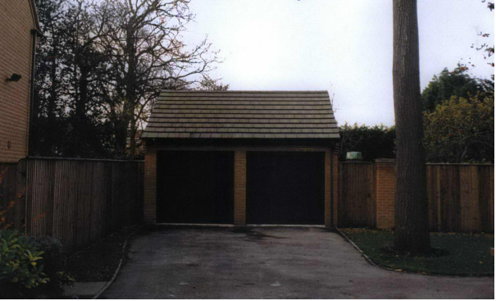

Figure 1: original garage

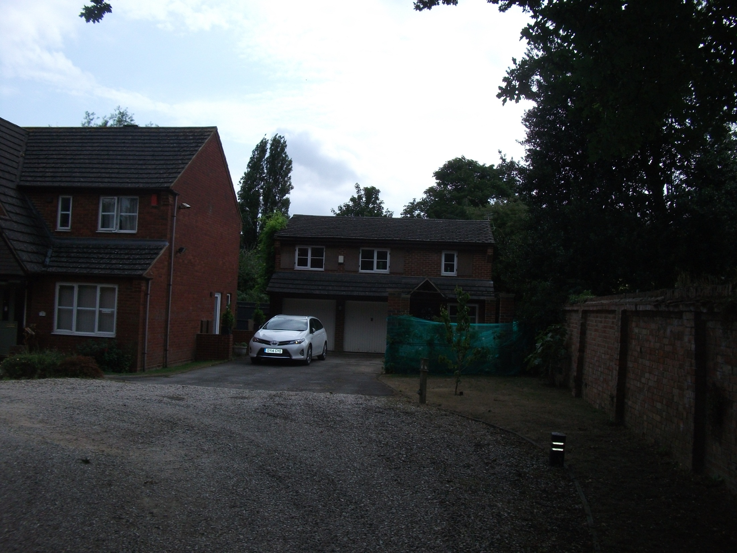

Figure 2: existing garage

28. In 2012, ref.: 12/01722/CEU, a certificate of lawfulness to certify that the ridge height at 5.9m is lawful was submitted and subsequently refused for the following reason:

The raising of the ridge of the garage building to a height of 5.90m contravenes the requirements of an Enforcement Notice ref: 01/00922/E, issued on 22nd May 2001. This notice requires the height of the ridge of the garage building to be restored to the dimensions and height approved in planning permission ref: 99/00928/NFH namely 5.75m above existing ground level.

29. An appeal was submitted however the Planning Inspectorate (PINS) would not determine the appeal for the following reason:

It appears that there is an effective enforcement notice in place which, under sections 191(2) and 285(1) of the Town and Country Planning Act 1990, prevents a lawful development certificate from being granted. For this reason, we (PINS) will take no further action on your appeal.

30. In May 2012, reiterated in November 2012, the Council informed the applicant that whilst the Council does not condone the raising of the roof, it will take no further action provided that no additional alterations are made to the roof because it does not consider it expedient or in the public interest to do so.

31. Given it is not considered expedient to enforce against the unauthorised raising of the roof officers consider that there is no good reason to refuse to regularise the situation and approve the current height of 8.85m as shown on the drawing entitled “Proposed Views” (side elevations) submitted as part of this application. A condition can be added to prevent any further raising of the roof.

Conclusion:

32. Members are recommended to approve the application subject to the conditions suggested.

Human Rights Act 1998

Officers have considered the Human Rights Act 1998 in reaching a recommendation to grant planning permission, subject to conditions. Officers have considered the potential interference with the rights of the owners/occupiers of surrounding properties under Article 8 and/or Article 1 of the First Protocol of the Act and consider that it is proportionate.

Officers have also considered the interference with the human rights of the applicant under Article 8 and/or Article 1 of the First Protocol caused by imposing conditions. Officers consider that the conditions are necessary to protect the rights and freedoms of others and to control the use of property in accordance with the general interest. The interference is therefore justifiable and proportionate.

Section 17 of the Crime and Disorder Act 1998

Officers have considered, with due regard, the likely effect of the proposal on the need to reduce crime and disorder as part of the determination of this application, in accordance with section 17 of the Crime and Disorder Act 1998. In reaching a recommendation to grant planning permission, officers consider that the proposal will not undermine crime prevention or the promotion of community safety.

Background Papers:

Contact Officer: Lisa Green
Extension: 2614
Date: 19th August 2015

